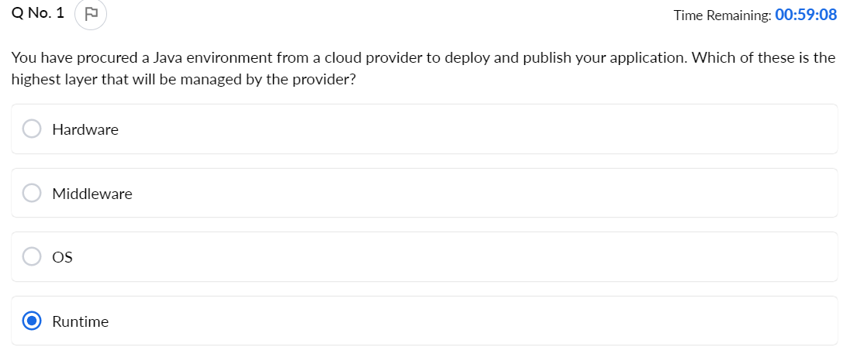

Time Remaining: **00:58:32**

Which of the following job roles will be affected when using a managed service for Map Reduce operations versus installing and manually setting up a Hadoop cluster in a set of provisioned VMs?



System Administrator



Data Scientist



Business Analyst



Data Architect

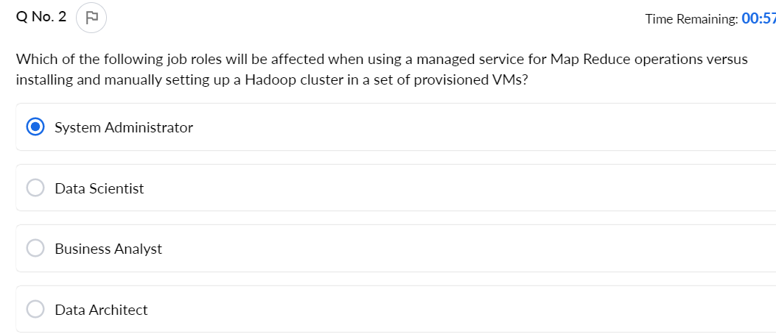

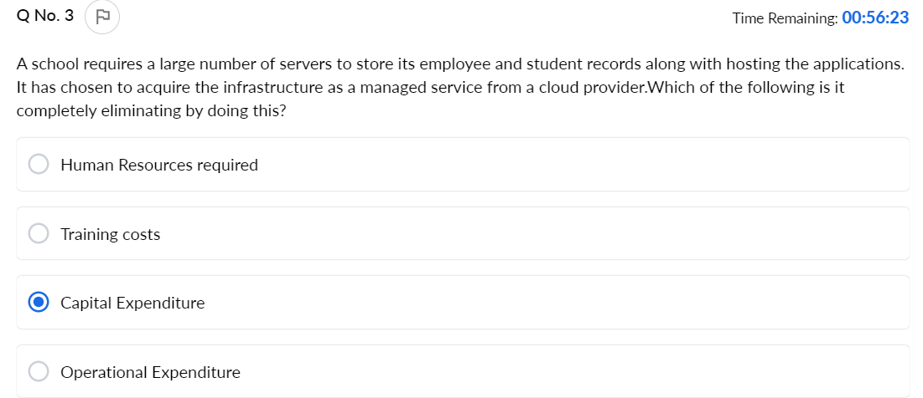

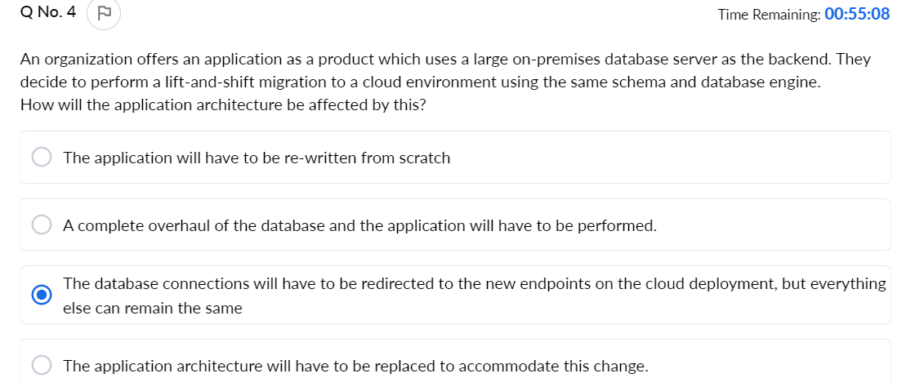

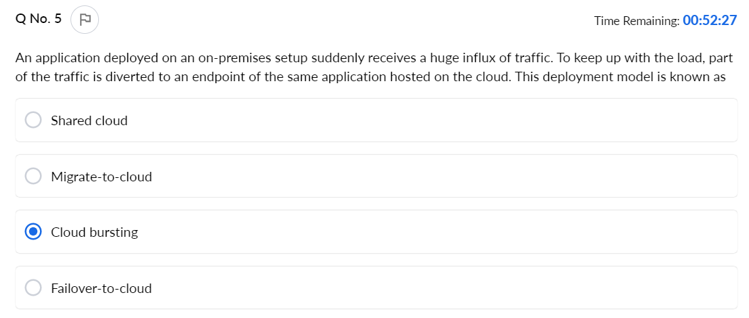

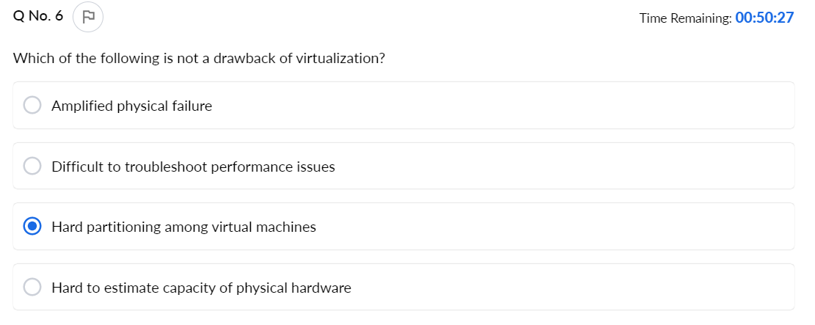

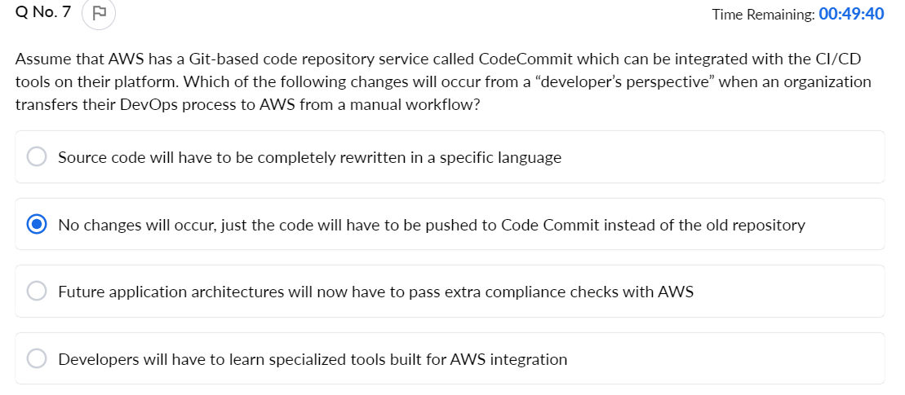

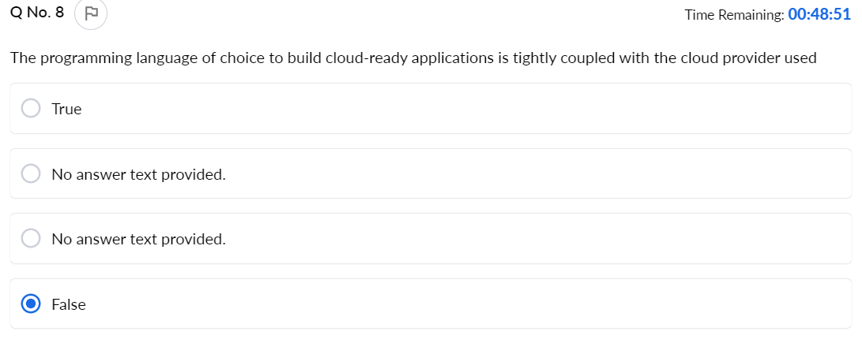

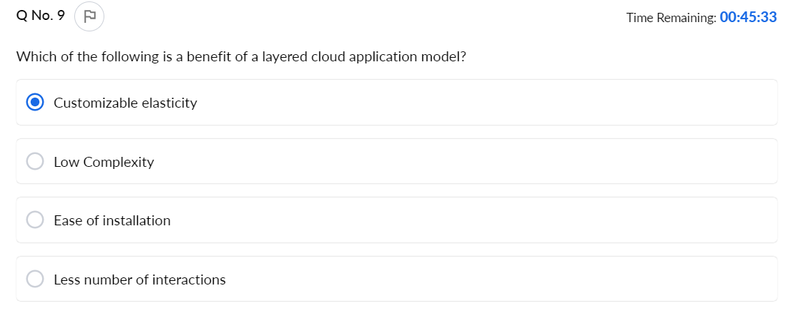

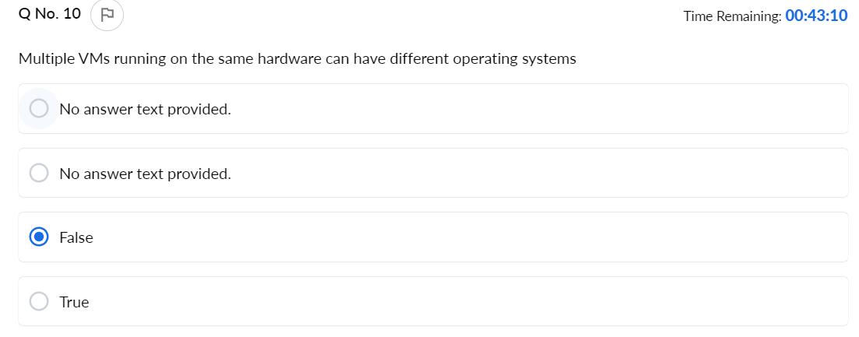

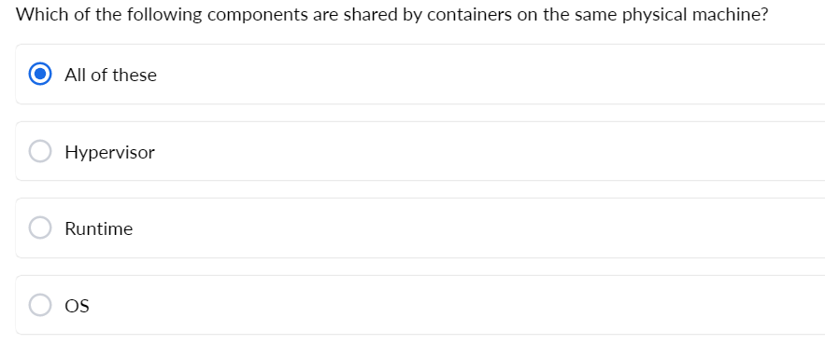

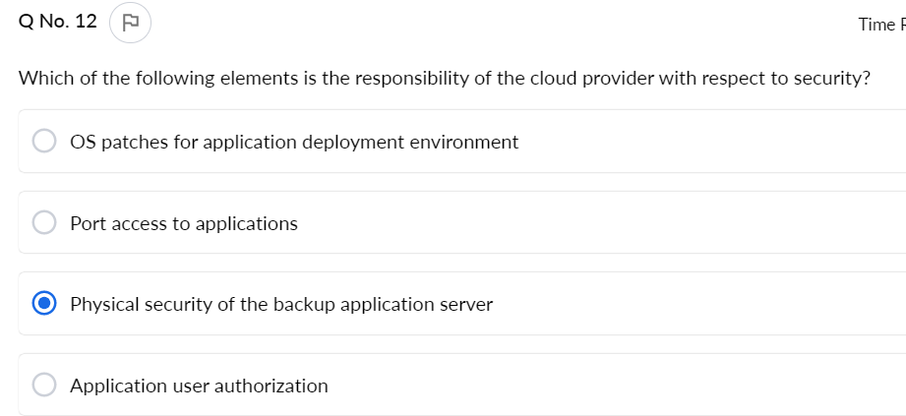

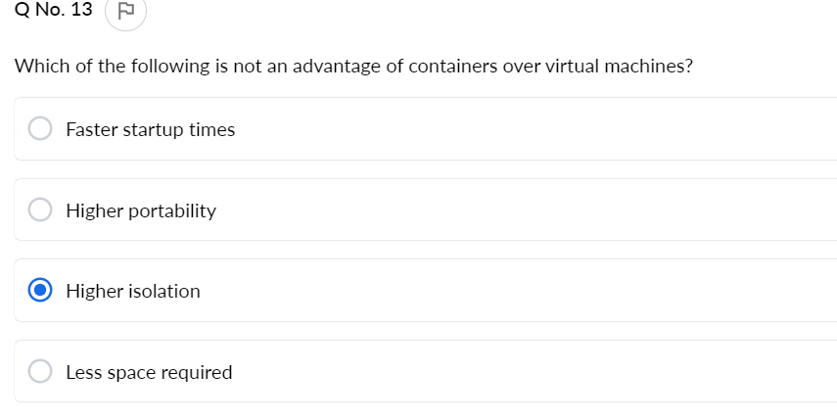

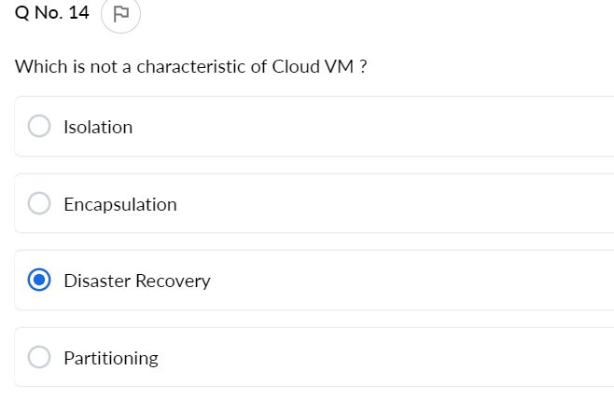

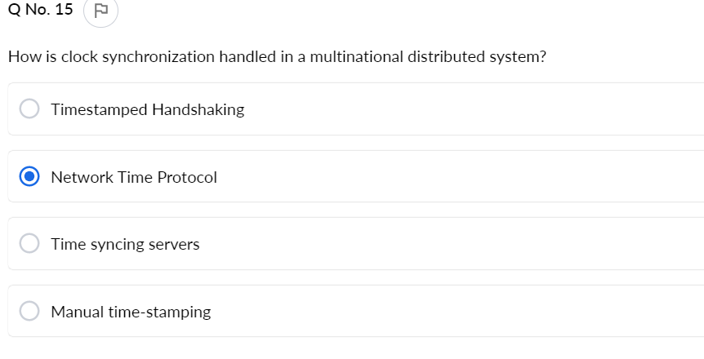

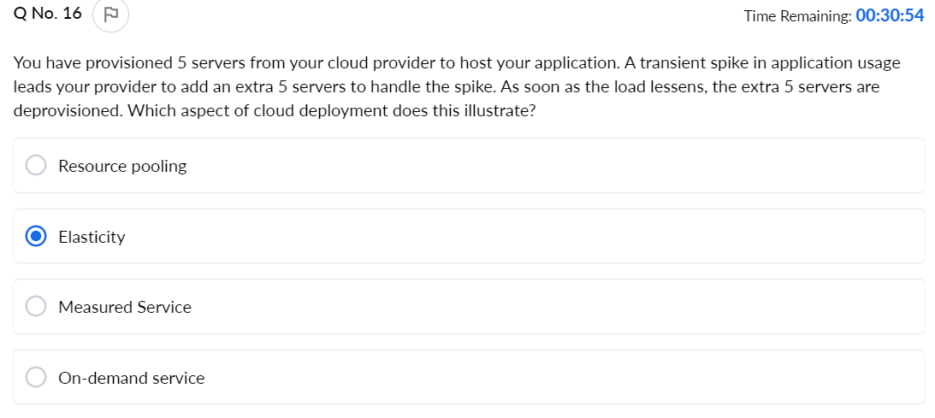

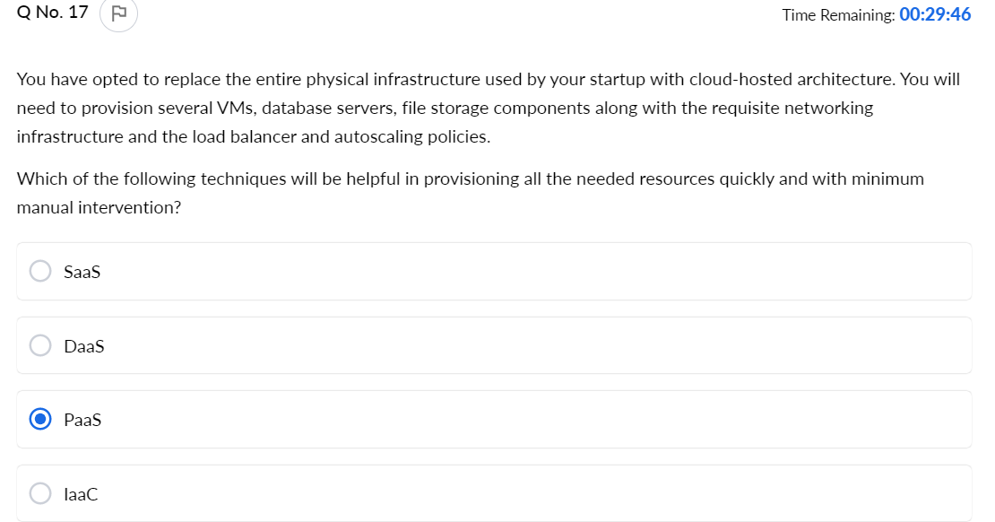

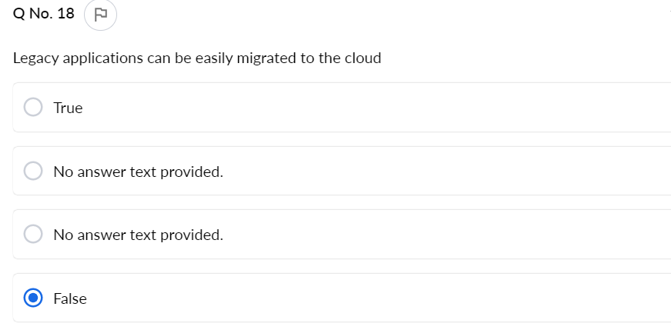

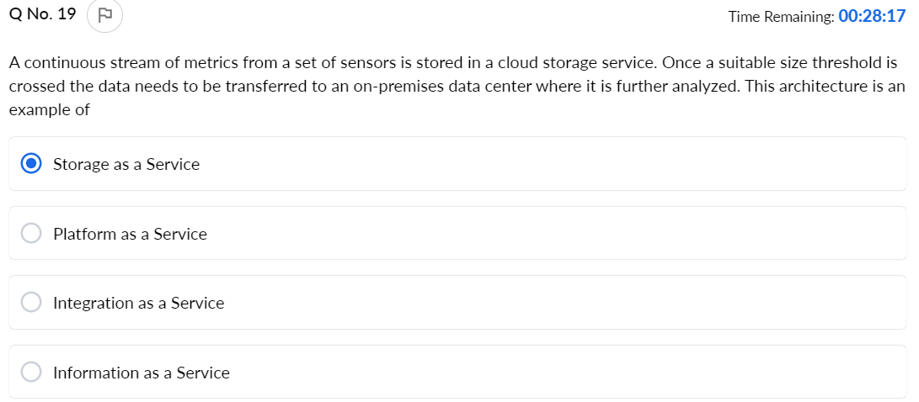

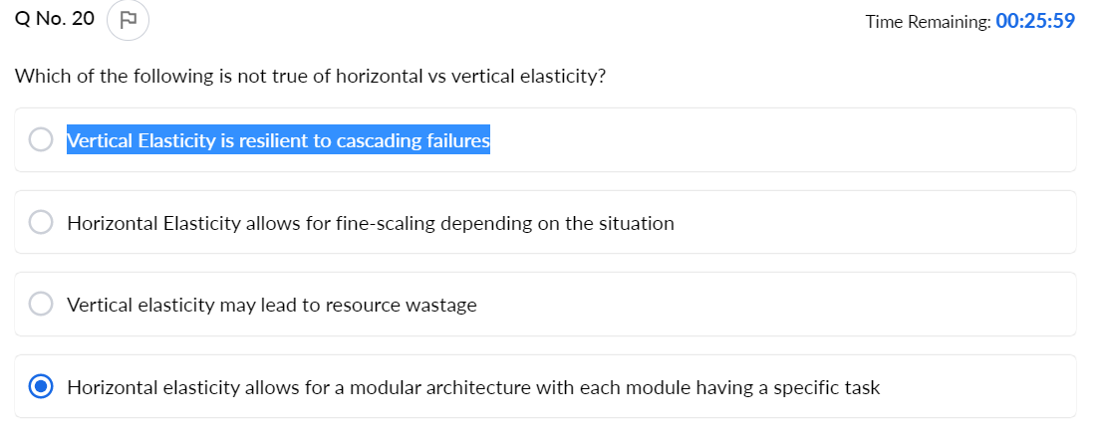

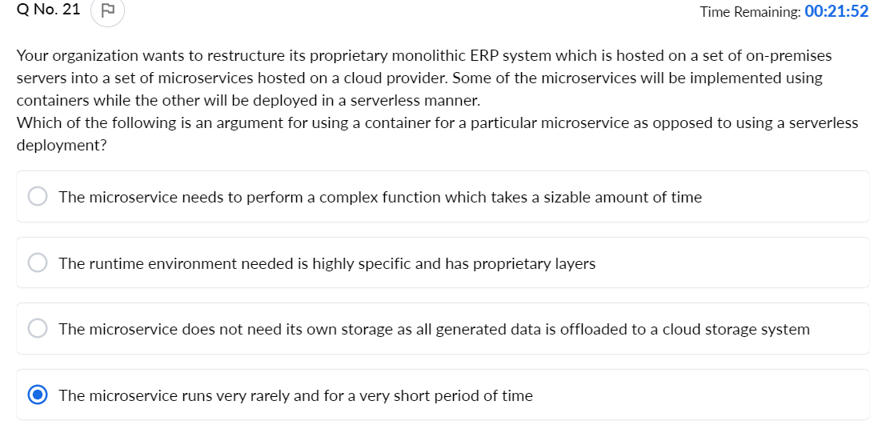

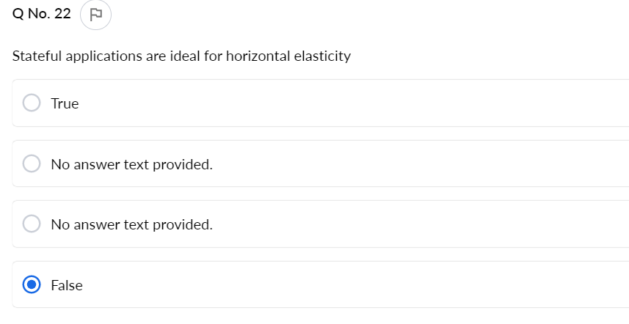

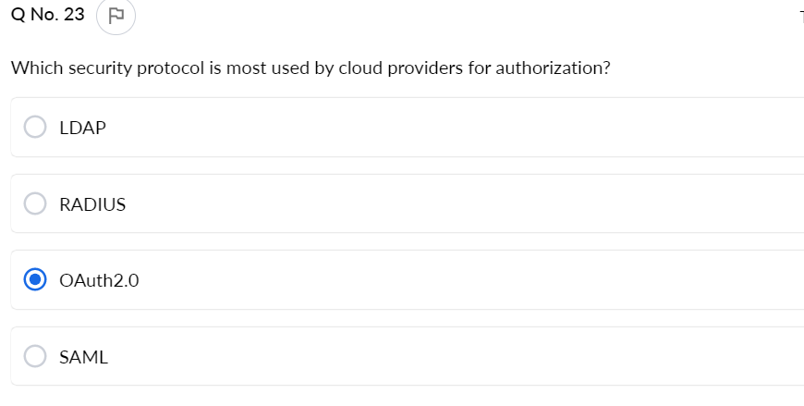

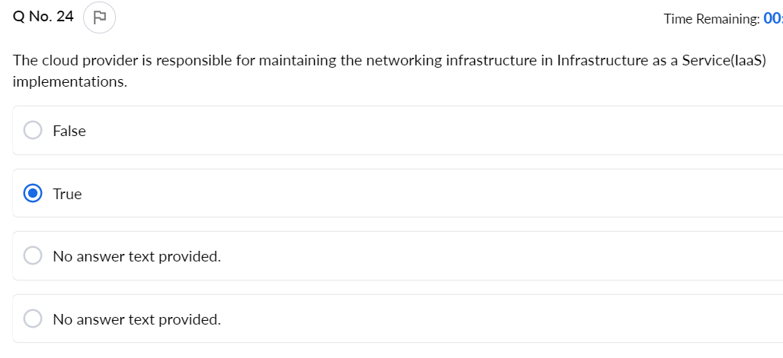

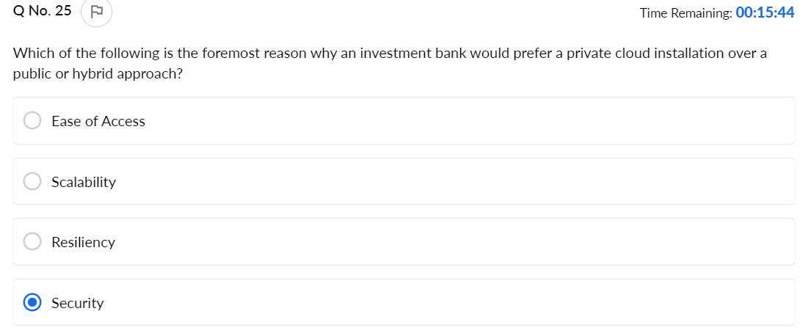

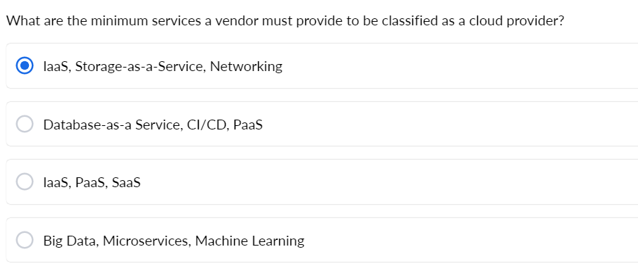

Correct Answer

An organization offers an application as a product which uses a large on-premises database server as the backend. They decide to perform a lift-and-shift migration to a cloud environment using the same schema and database engine.  
How will the application architecture be affected by this?



A complete overhaul of the database and the application will have to be performed.



The database connections will have to be redirected to the new endpoints on the cloud deployment, but everything else can remain the same

You Selected

The application will have to be re-written from scratch



The application architecture will have to be replaced to accommodate this change.

Explanation: Interacting with a cloud database is no different than interacting with an on-premises setup. The same drivers and connection strings will be used, with a different endpoint URL

**Question No: 2**

Correct Answer

Which security protocol is most used by cloud providers for authorization?



SAML



LDAP



OAuth2.0

You Selected

RADIUS

Explanation: OAuth is an open standard used for authenticating users in applications and websites without actually providing the access credentials of the information source

**Question No: 3**

Correct Answer

Stateful applications are ideal for horizontal elasticity



No answer text provided.



No answer text provided.



True



False

You Selected

Explanation: Stateful applications lead to session affinity, which by its very nature, cannot be used in horizontal elasticity because of the transient nature of the resources created.

**Question No: 4**

Correct Answer

A school requires a large number of servers to store its employee and student records along with hosting the applications. It has chosen to acquire the infrastructure as a managed service from a cloud provider.Which of the following is it completely eliminating by doing this?



Training costs



Operational Expenditure



Human Resources required



Capital Expenditure

You Selected

Explanation: The school will not have to pay any upfront costs for the infrastructure, therefore no capital is required. The only expenses will be the runtime expenditure , based on usage, and human resources and their training, which is a one-time minimal cost.

**Question No: 5**

Correct Answer

Assume that AWS has a Git-based code repository service called CodeCommit which can be integrated with the CI/CD tools on their platform. Which of the following changes will occur from a “developer’s perspective” when an organization transfers their DevOps process to AWS from a manual workflow?



Developers will have to learn specialized tools built for AWS integration



Source code will have to be completely rewritten in a specific language



Future application architectures will now have to pass extra compliance checks with AWS



No changes will occur, just the code will have to be pushed to Code Commit instead of the old repository

You Selected

Explanation: Cloud CI/CD tools are built to be highly compatible with a variety of programming languages and are architecture-independent. No changes will be needed for the developers’ workflow.

**Question No: 6**

Correct Answer

Which of the following is not a drawback of virtualization?



Hard to estimate capacity of physical hardware



Hard partitioning among virtual machines

You Selected

Amplified physical failure



Difficult to troubleshoot performance issues

Explanation: VMs run in isolation and hard partitioning among different VMs running on the same physical host ensures the security of the data of the customers using them

**Question No: 7**

Correct Answer

What are the minimum services a vendor must provide to be classified as a cloud provider?



IaaS, PaaS, SaaS



IaaS, Storage-as-a-Service, Networking

You Selected

Database-as-a Service, CI/CD, PaaS



Big Data, Microservices, Machine Learning

Explanation: Computing, Storage and Networking are the basic building blocks of any application architecture. These services must be available to be classified as a cloud provider.

**Question No: 8**

Correct Answer

Multiple VMs running on the same hardware can have different operating systems



No answer text provided.



False



No answer text provided.



True

You Selected

Explanation: One of the advantages of VMs is that multiple operating systems like Centos, Ubuntu, and Windows and be run simultaneously on the same machine.

**Question No: 9**

Correct Answer

Which of the following elements is the responsibility of the cloud provider with respect to security?



Port access to applications



Physical security of the backup application server

You Selected

OS patches for application deployment environment



Application user authorization

Explanation: The cloud provider has to make sure the servers are in a secure location and cannot be tampered with

**Question No: 10**

Correct Answer

Which of the following is not an advantage of containers over virtual machines?



Less space required



Faster startup times



Higher portability



Higher isolation

You Selected

Explanation: Containers provide process-level isolation, while VMs provide a higher OS-level isolation

**Question No: 11**

Correct Answer

An application deployed on an on-premises setup suddenly receives a huge influx of traffic. To keep up with the load, part of the traffic is diverted to an endpoint of the same application hosted on the cloud. This deployment model is known as



Shared cloud



Failover-to-cloud



Migrate-to-cloud



Cloud bursting

You Selected

Explanation: A cloudburst architecture will distribute traffic between an on-premises and a cloud deployment to ease the load on both

**Question No: 12**

Correct Answer

Which of the following is not true of horizontal vs vertical elasticity?



Horizontal Elasticity allows for fine-scaling depending on the situation



Vertical Elasticity is resilient to cascading failures

You Selected

Horizontal elasticity allows for a modular architecture with each module having a specific task



Vertical elasticity may lead to resource wastage

Explanation: Vertical elasticity means just increasing the capacity of a single machine. Therefore if a cluster has few large machines, one machine failure will put significant stress on the rest which may cause cascading failure.. However systems like databases are designed for vertical scaling.

**Question No: 13**

Correct Answer

A continuous stream of metrics from a set of sensors is stored in a cloud storage service. Once a suitable size threshold is crossed the data needs to be transferred to an on-premises data center where it is further analyzed. This architecture is an example of



Information as a Service



Storage as a Service



Integration as a Service

You Selected

Platform as a Service

Explanation: Integration as a Service among other things also denotes the coupling and free flow of data between an on-premises and cloud storage systems

**Question No: 14**

Correct Answer

Which is not a characteristic of Cloud VM ?



Disaster Recovery

You Selected

Isolation



Partitioning



Encapsulation

Explanation:Recovery from VM failures has to be manually set up using load balancer groups and auto-scaling policies.

**Question No: 15**

Correct Answer

Legacy applications can be easily migrated to the cloud



False

You Selected

No answer text provided.



True



No answer text provided.

Explanation: Legacy applications can be built as unwieldy monoliths in unsupported languages that may prove to be difficult to migrate to the cloud. In addition there can be dependencies on other applications that are running on-prem.

**Question No: 16**

Correct Answer

Which of the following is the foremost reason why an investment bank would prefer a private cloud installation over a public or hybrid approach?



Security

You Selected

Scalability



Resiliency



Ease of Access

Explanation: A private cloud, while not outright more secure than a public cloud offering, will allow more finely grained security controls

**Question No: 17**

Correct Answer

Which of the following is a benefit of a layered cloud application model?



Customizable elasticity

You Selected

Ease of installation



Less number of interactions



Low Complexity

Explanation: Every layer can be scaled independently according to the needs of the application and traffic. Breaking an application in small chunks and hosting independently is the building block of microservices

**Question No: 18**

Correct Answer

Your organization wants to restructure its proprietary monolithic ERP system which is hosted on a set of on-premises servers into a set of microservices hosted on a cloud provider. Some of the microservices will be implemented using containers while the other will be deployed in a serverless manner.  
Which of the following is an argument for using a container for a particular microservice as opposed to using a serverless deployment?



The microservice needs to perform a complex function which takes a sizable amount of time

You Selected

The runtime environment needed is highly specific and has proprietary layers



The microservice does not need its own storage as all generated data is offloaded to a cloud storage system



The microservice runs very rarely and for a very short period of time

Explanation: A serverless implementation is meant for short bursts of activity or tasks. A container can be used when a prolonged task needs to be performed

**Question No: 19**

Correct Answer

How is clock synchronization handled in a multinational distributed system?



Network Time Protocol

You Selected

Manual time-stamping



Timestamped Handshaking



Time syncing servers

Explanation: NTP is a networking protocol designed for clock synchronization relative to the epoch on January 1, 1900 00.00hrs. Unix epoch uses Jan 1 1970, 00.00 hours

**Question No: 20**

Correct Answer

The cloud provider is responsible for maintaining the networking infrastructure in Infrastructure as a Service(IaaS) implementations.



No answer text provided.



No answer text provided.



False



True

You Selected

Explanation: Every physical component is maintained by the cloud provider in IaaS systems.

**Question No: 21**

Correct Answer

Which of the following components are shared by containers on the same physical machine?



All of these

You Selected

Hypervisor



Runtime



OS

Explanation: Two containers running on the same machine will share everything except application libraries. However, the sharing is from the perspective of various runtimes, it will not share the user data segment which will ensure the data remains isolated.

**Question No: 22**

Correct Answer

You have opted to replace the entire physical infrastructure used by your startup with cloud-hosted architecture. You will need to provision several VMs, database servers, file storage components along with the requisite networking infrastructure and the load balancer and autoscaling policies.

Which of the following techniques will be helpful in provisioning all the needed resources quickly and with minimum manual intervention?



PaaS



IaaC

You Selected

SaaS



DaaS

Explanation: IaaC involves creating machine-readable files describing the required hardware resources, which can then be accepted by the cloud provider service who will provision the required hardware. These files can then be stored and modified for easy replication of the architecture as required

**Question No: 23**

Correct Answer

You have provisioned 5 servers from your cloud provider to host your application. A transient spike in application usage leads your provider to add an extra 5 servers to handle the spike. As soon as the load lessens, the extra 5 servers are deprovisioned. Which aspect of cloud deployment does this illustrate?



On-demand service



Resource pooling



Elasticity

You Selected

Measured Service

Explanation: Elasticity ensure that your capacity matches the current load on your infrastructure

**Question No: 24**

Correct Answer

You have procured a Java environment from a cloud provider to deploy and publish your application. Which of these is the highest layer that will be managed by the provider?



Runtime

You Selected

Middleware



OS



Hardware

Explanation: The question describes a PaaS application where the cloud provider is responsible for and will control all aspects of the deployment below the runtime layer. Some examples are elastic beanstalk in AWS and Google App Engine.

**Question No: 25**

Correct Answer

Which of the following job roles will be affected when using a managed service for Map Reduce operations versus installing and manually setting up a Hadoop cluster in a set of provisioned VMs?



Business Analyst



System Administrator

You Selected

Data Scientist



Data Architect

Explanation: The maintenance and updates of a managed service is taken care of by the cloud provider, with minimal interference from the system administrator. The rest of the job roles can carry on interacting with the cluster just as they would with an on-premises setup.